**The Groucho Club - an infamous beacon for London's creative elite.**

Struggling to think of a place to meet friends is a classic conundrum, one might choose the local pub, check TripAdvisor or order in and host an evening each. In the case of a certain group of London based publishers, they decided to create and exclusive members club. 30 years on from its inception, The Groucho Club is an infamous beacon for London's creative elite.

The club is home to many well-known names. On entrance, it wouldn't be unlikely to be in the company of the likes of Stephen Fry, Noel Gallagher, Lily Allen, Matthew Bellamy and Pixie Geldof. But, before anyone applies for membership, they will need to be recommended by two members of the club, show that they share the clubs 'maverick' spirit and have their membership fee ready. Should be easy, right?

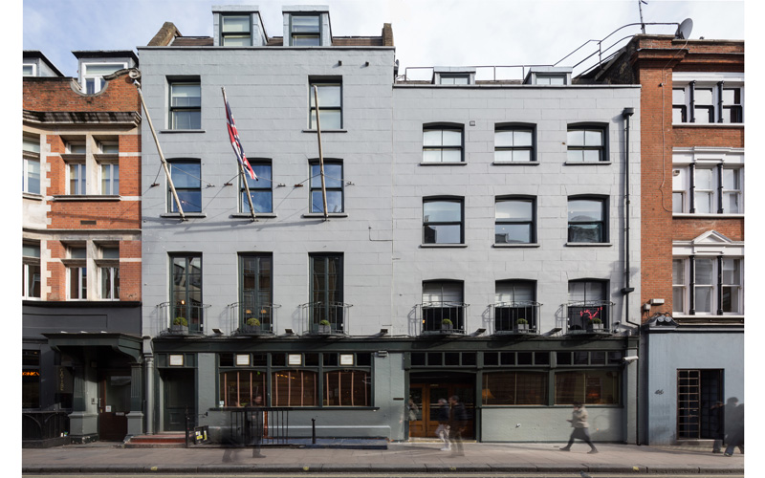

Looking on from Dean Street, the Groucho club looks understated, but this is just a facade. Behind the stylish exterior is a thriving scene, which has stayed fashionable throughout some extremely changeable times.

Within, an impressive selection of timeless art in situ with elegant and homely interior decor provides a comfortable atmosphere tailored perfectly to their audience. Seven distinctively different rooms for event hire purposes and 20 guest rooms ensure members have everything they need. 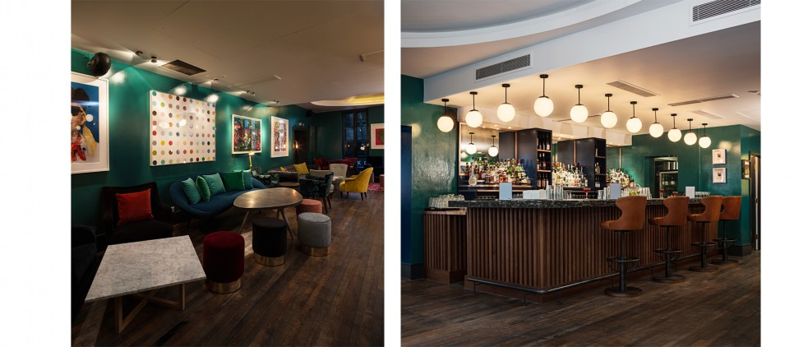

The unique attention to detail means that The Groucho Club is no stranger to bespoke services and choosing timeless pieces. Working with Smart Hospitality Supplies, they looked to enhance the character of the interior decor even further with bespoke menu covers.

To work in with the timeless nature of the art and decor, a green buckram was chosen as the covering material. Having been used for centuries in book making, buckram was the ideal solution in creating a personal touch for members of the creative industries. Highlighted throughout the clubs interior, mid green makes a bold statement whilst hinting at British tradition.

Blank space is key in design. Ensuring the logo wasn't overpowering was essential in continuing the sense of understatement and anonymity that The Groucho Club emits and provides to its members. Blind embossing the logo does this in an elegant and subtle way. Placement to the centre right almost represents a door handle. This touches on the exclusivity of the club as a whole.

From the beginning, the attraction of The Groucho Club has been that it brings a sophisticated alternative to the usual socialising patterns within the creative industries. Having such a selective application process has helped ensure that it's members are on a level playing field. "Secretly, people like not having to be the coolest person in the room. It's the same with fame. People want to be treated kindly, not be stared at." As the 1987 Groucho Club Manager, Mary-Lou-Sturridge, reveals. The Groucho Club has provided an anonymity, an untapped need for a get-away from stardom and everything that comes with it. 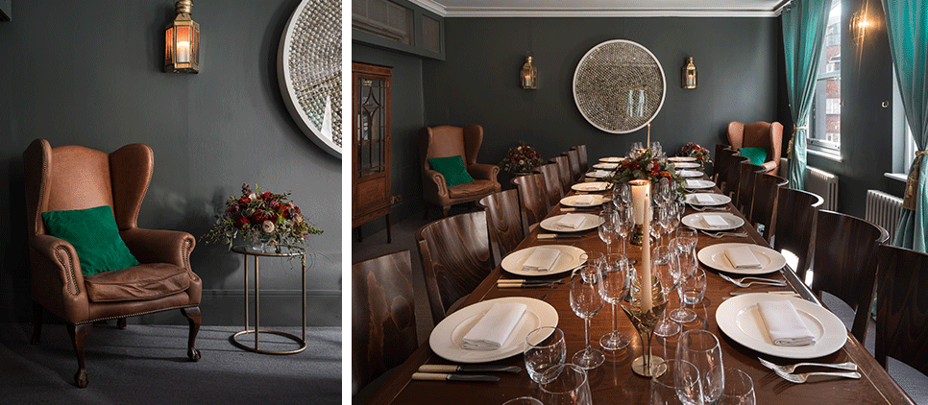

The founders tailored the club to their own tastes and as a result, have attracted 4,000 like-minded members. The Groucho Club is in the perfect position to tailor its service and has found popularity in eccentricity and, ironically, omission.

Groucho Marx's comment about not wanting to be a member of any club that would have him may have been the name sake for this club, but he would be the first at the door here.